input.doc Name:_____________________________

1) Determine the equation of each line shown below.

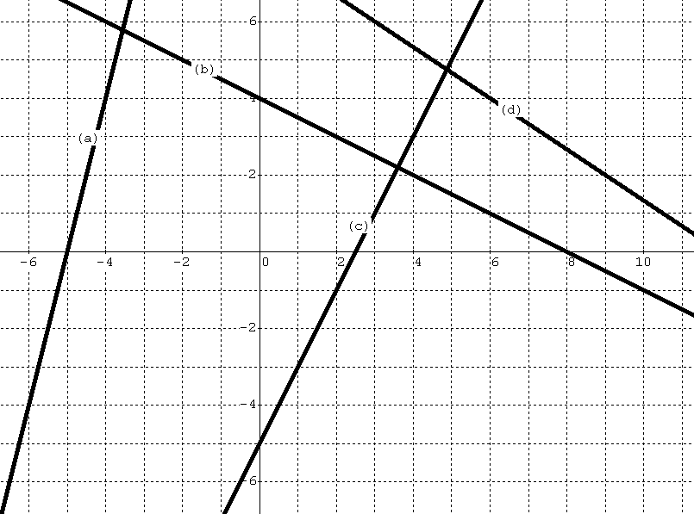
a) _________________________

b) _________________________

c) _________________________

d) _________________________

2) Determine the equation of each line given the information below.

a) point on line: (10,2) slope = 1/2

b) x-intercept of -5, slope = 1

c) Line passes through points (2,-1) and (5,-3)

3) Mr. Haas got a summer job delivering pizzas. He decided that the delivery charge should be a linear equation, where the cost of delivery is a function of the distance from the pizza restaurant. The table shows the cost for four different distances.
Distance  (miles) | Cost  (dollars)
2 | 2
4 | 3
6 | 4
8 | 5

a) Find the linear equation represented by the data in the table.

b) What does the slope tell you in terms of distance and cost?

c) What is the y-intercept? What does it tell you in terms of distance and cost?

d) Use your equation to determine the cost of delivering a pizza 1000 miles

e) Use your equation to determine the delivery distance where the cost would be $0.



